

Osteopathy Board of Australia

Registrant data

Reporting period: 1 April 2018 – 30 June 2018

Table of contents
Introduction 3
Principal place of practice 4
1. Registration type 4
1. Endorsements 4
Age group 5
2. Registration type and subtype 5
Gender 6
3. Registration type 6
4. Percentage 6

Introduction
The role of the Osteopathy Board of Australia (the Board) include:
- registering osteopaths and students
- developing standards, codes and guidelines for the osteopathy profession
- handling notifications, complaints, investigations and disciplinary hearings
- overseeing the assessment of overseas trained practitioners who wish to practise in Australia, and
- approving accreditation standards and accredited courses of study.
The Board’s functions are supported by the Australian Health Practitioner Regulation Agency (AHPRA). For information about legislation governing our operations see About AHPRA at www.ahpra.gov.au/About-AHPRA/What-We-Do/Legislation.aspx.
The Board has analysed its registration data and produced a number of statistical breakdowns about registrants to share with the profession and community. The Board shares these breakdowns regularly.
For more information on osteopathy registration, please see the Board’s website: www.osteopathyboard.gov.au/Registration.aspx

Principal place of practice
- Registration type
  - Registration type by principal place of practice
Registration type | ACT | NSW | NT | QLD | SA | TAS | VIC | WA | No PPP | Total
General | 38 | 563 | 3 | 208 | 35 | 45 | 1,304 | 61 | 30 | 2,287
Provisional |  |  |  | 3 |  |  | 3 | 1 |  | 7
Limited
Non-practising |  | 19 |  | 5 | 1 |  | 51 | 1 | 18 | 95
Total | 38 | 582 | 3 | 216 | 36 | 45 | 1,358 | 63 | 48 | 2,389

  - Registration type by principal place of practice percentages
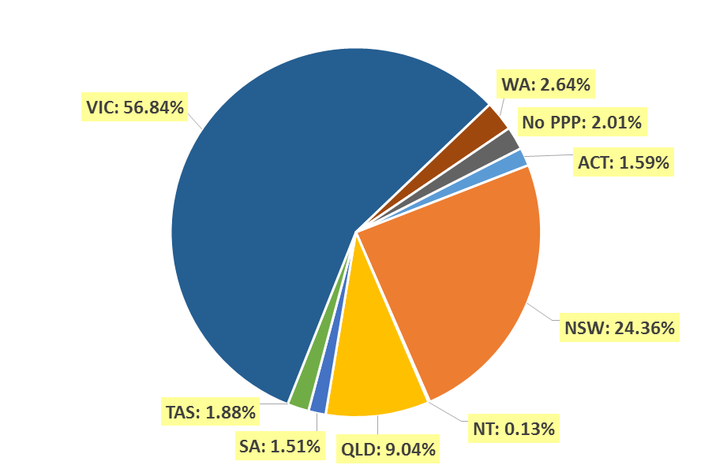

Endorsements
  - Endorsements
Endorsement | ACT | NSW | NT | QLD | SA | TAS | VIC | WA | No PPP | Total
Acupuncture |  |  |  |  |  |  | 2 |  |  | 2

Age group
- Registration type and subtype
  - Registration by age group
Age group | General | Provisional | Limited | Non-practising | Total
U - 25 | 101 | 2 |  | 2 | 105
25 - 29 | 467 | 2 |  | 15 | 484
30 - 34 | 420 | 2 |  | 23 | 445
35 - 39 | 427 |  |  | 19 | 446
40 - 44 | 296 | 1 |  | 12 | 309
45 - 49 | 199 |  |  | 5 | 204
50 - 54 | 108 |  |  | 2 | 110
55 - 59 | 103 |  |  | 3 | 106
60 - 64 | 79 |  |  | 7 | 86
65 - 69 | 52 |  |  | 3 | 55
70 - 74 | 24 |  |  |  | 24
75 - 79 | 5 |  |  | 3 | 8
80+ | 6 |  |  | 1 | 7
Total | 2,287 | 7 |  | 95 | 2,389

  - Registrants by Age Group

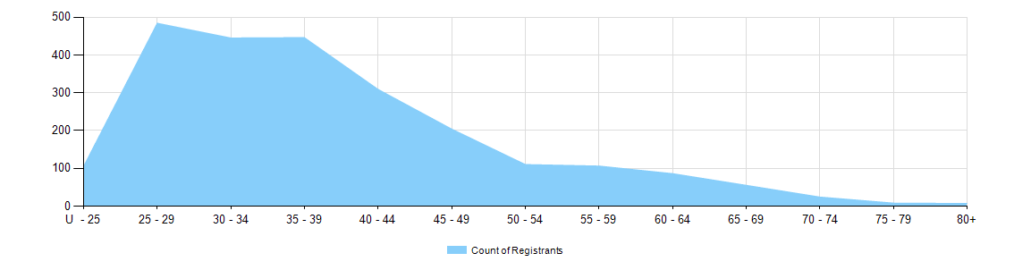

Gender
- Registration type
  - Registration type by gender
Gender | Registration type | ACT | NSW | NT | QLD | SA | TAS | VIC | WA | No PPP | Total
Female | General | 17 | 262 | 1 | 94 | 19 | 24 | 780 | 32 | 16 | 1,245
Female | Provisional |  |  |  | 2 |  |  | 2 |  |  | 4
Female | Non-practising |  | 9 |  | 1 |  |  | 36 |  | 12 | 58
Total female |  | 17 | 271 | 1 | 97 | 19 | 24 | 818 | 32 | 28 | 1,307
Male | General | 21 | 301 | 2 | 114 | 16 | 21 | 524 | 29 | 14 | 1,042
Male | Provisional |  |  |  | 1 |  |  | 1 | 1 |  | 3
Male | Non-practising |  | 10 |  | 4 | 1 |  | 15 | 1 | 6 | 37
Total male |  | 21 | 311 | 2 | 119 | 17 | 21 | 540 | 31 | 20 | 1,082
Total |  | 38 | 582 | 3 | 216 | 36 | 45 | 1,358 | 63 | 48 | 2,389

- Percentage
  - Registration by gender percentages
Gender | ACT | NSW | NT | QLD | SA | TAS | VIC | WA | No PPP | Total
Female | 44.7% | 46.6% | 33.3% | 44.9% | 52.8% | 53.3% | 60.2% | 50.8% | 58.3% | 54.7%
Male | 55.3% | 53.4% | 66.7% | 55.1% | 47.2% | 46.7% | 39.8% | 49.2% | 41.7% | 45.3%

