

Osteopathy Board of Australia

Registrant Data

Reporting period: 1 January 2017 – 31 March 2017

Table of contents
Introduction 3
Principal Place of Practice 4
1. Registration Type 4
2. Endorsements 4
Age Group 5
3. Registration Type and Sub type 5
Gender 6
4. Registration Type 6
5. Percentage 6

Introduction
The role of the Osteopathy Board of Australia (the Board) include:
- registering osteopaths and students
- developing standards, codes and guidelines for the osteopathy profession
- handling notifications, complaints, investigations and disciplinary hearings
- overseeing the assessment of overseas trained practitioners who wish to practise in Australia, and
- approving accreditation standards and accredited courses of study.
The Board’s functions are supported by the Australian Health Practitioner Regulation Agency (AHPRA). For information about legislation governing our operations see About AHPRA at http://www.ahpra.gov.au/About-AHPRA/What-We-Do/Legislation.aspx.
The Board has analysed its registration data and produced a number of statistical breakdowns about registrants to share with the profession and community. The Board shares these breakdowns regularly.
For more information on osteopathy registration, please see the Board’s website: http://www.osteopathyboard.gov.au/Registration.aspx

Principal Place of Practice
- Registration Type
  - Registration type by principal place of practice
Registration Type | ACT | NSW | NT | QLD | SA | TAS | VIC | WA | No PPP | Total
General | 34 | 540 | 3 | 193 | 35 | 41 | 1,182 | 60 | 32 | 2,120
Provisional | 1 | 5 |  | 4 | 1 |  | 1 | 1 |  | 13
Non-practising |  | 19 |  | 8 | 2 |  | 42 | 1 | 14 | 86
Total | 35 | 564 | 3 | 205 | 38 | 41 | 1,225 | 62 | 46 | 2,219

  - Registration type by principal place of practice percentages

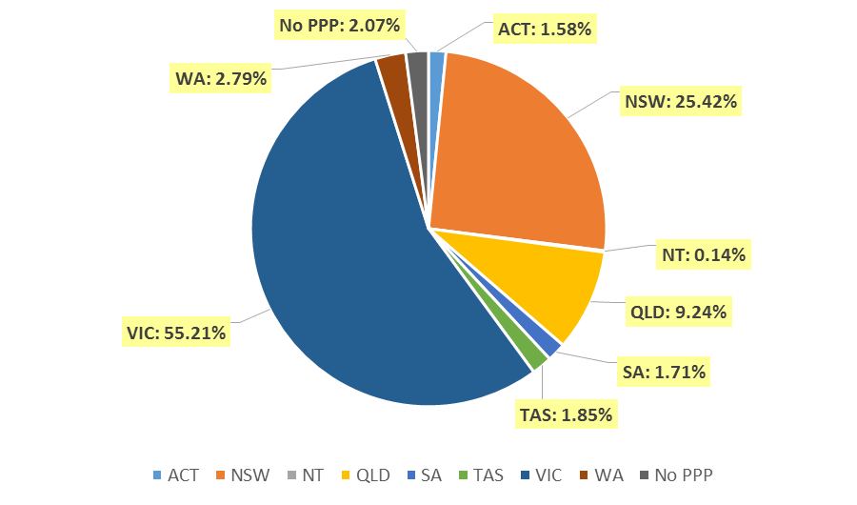

Endorsements
  - Endorsements
Endorsement | ACT | NSW | NT | QLD | SA | TAS | VIC | WA | No PPP | Total
Acupuncture |  |  |  |  |  |  | 2 |  |  | 2

Age Group
- Registration Type and Sub type
  - Registration by age group
Age Group | General | Provisional | Non-practising | Total
U - 25 | 93 | 2 |  | 95
25 - 29 | 429 | 7 | 17 | 453
30 - 34 | 406 | 1 | 20 | 427
35 - 39 | 395 | 1 | 17 | 413
40 - 44 | 266 | 2 | 9 | 277
45 - 49 | 167 |  | 3 | 170
50 - 54 | 103 |  | 3 | 106
55 - 59 | 106 |  | 6 | 112
60 - 64 | 79 |  | 5 | 84
65 - 69 | 48 |  | 1 | 49
70 - 74 | 17 |  |  | 17
75 - 79 | 7 |  | 4 | 11
80+ | 4 |  | 1 | 5
Total | 2,120 | 13 | 86 | 2,219

  - Registrants by Age Group

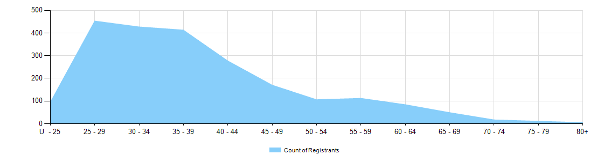

Gender
- Registration Type
  - Registration type by gender
Gender | Registration Type | ACT | NSW | NT | QLD | SA | TAS | VIC | WA | No PPP | Total
Female | General | 15 | 238 |  | 86 | 22 | 23 | 720 | 30 | 14 | 1,148
Female | Provisional |  | 3 |  | 3 |  |  | 1 | 1 |  | 8
Female | Non-practising |  | 9 |  | 5 |  |  | 32 |  | 9 | 55
Total Female |  | 15 | 250 |  | 94 | 22 | 23 | 753 | 31 | 23 | 1,211
Male | General | 19 | 302 | 3 | 107 | 13 | 18 | 462 | 30 | 18 | 972
Male | Provisional | 1 | 2 |  | 1 | 1 |  |  |  |  | 5
Male | Non-practising |  | 10 |  | 3 | 2 |  | 10 | 1 | 5 | 31
Total Male |  | 20 | 314 | 3 | 111 | 16 | 18 | 472 | 31 | 23 | 1,008
Total |  | 35 | 564 | 3 | 205 | 38 | 41 | 1,225 | 62 | 46 | 2,219

- Percentage
  - Registration by Gender Percentages
Gender | ACT | NSW | NT | QLD | SA | TAS | VIC | WA | No PPP | Total
Female | 42.9% | 44.3% | .0% | 45.9% | 57.9% | 56.1% | 61.5% | 50.0% | 50.0% | 54.6%
Male | 57.1% | 55.7% | 100.0% | 54.1% | 42.1% | 43.9% | 38.5% | 50.0% | 50.0% | 45.4%

