Osteopathy Registrant Data: March 2013

Published April 2013

Introduction
The functions of the Osteopathy Board of Australia include:
- registering osteopaths and students
- developing standards, codes and guidelines for the osteopathy profession
- handling notifications, complaints, investigations and disciplinary hearings
- assessing overseas trained practitioners who wish to practise in Australia
- approving accreditation standards and accredited courses of study.

The Board’s functions are supported by Australian Health Practitioner Regulation Agency (AHPRA). For information about legislation governing our operations see AHPRA's Legislation & Publications at http://www.ahpra.gov.au/Legislation-and-Publications.aspx

The Board has analysed its registration data and produced a number of statistical breakdowns about registrants to share with the profession and community. The Board shares these breakdowns regularly.

For more information on osteopathy registration, please see the Board’s website:
www.osteopathyboard.gov.au/Registration.aspx

Index of Tables
Osteopaths: State and territory by registration type 2
Osteopaths: Age by registration type 3
Osteopaths: Gender by state and territory by registration type 4
Osteopaths: Endorsement type by state and territory 4

Osteopaths: State and territory by registration type
State | General | Limited | Non-practising | Total | % By State
 |  | Postgraduate training or supervised practice
ACT | 29 |  | 1 | 30 | 1.7%
NSW | 496 |  | 17 | 513 | 29.07%
NT | 1 |  |  | 1 | 0.06%
QLD | 148 |  | 5 | 153 | 8.67%
SA | 34 |  | 2 | 36 | 2.04%
TAS | 43 |  |  | 43 | 2.44%
VIC | 863 |  | 42 | 905 | 51.27%
WA | 51 |  |  | 51 | 2.89%
Not Stated | 23 | 2 | 8 | 33 | 1.87%
Total | 1,688 | 2 | 75 | 1,765

% By state and territory

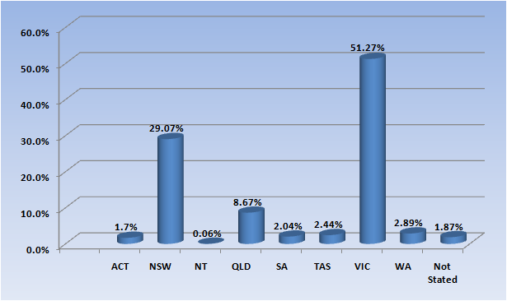

Osteopaths: Age by registration type
Age Group | General | Limited | Non-practising | Total | % By Age Group
 |  | Postgraduate training or supervised practice
21 - 25 | 110 |  |  | 110 | 6.23%
26 - 30 | 328 |  | 21 | 349 | 19.77%
31 - 35 | 371 | 2 | 25 | 398 | 22.55%
36 - 40 | 262 |  | 12 | 274 | 15.52%
41 - 45 | 182 |  | 2 | 184 | 10.42%
46 - 50 | 111 |  | 3 | 114 | 6.46%
51 - 55 | 109 |  | 1 | 110 | 6.23%
56 - 60 | 91 |  | 2 | 93 | 5.27%
61 - 65 | 66 |  | 4 | 70 | 3.97%
66 - 70 | 32 |  | 1 | 33 | 1.87%
71 - 75 | 16 |  | 2 | 18 | 1.02%
76 - 80 | 7 |  | 1 | 8 | 0.45%
81 - 85 | 3 |  | 1 | 4 | 0.23%
Total | 1,688 | 2 | 75 | 1,765

% By age group
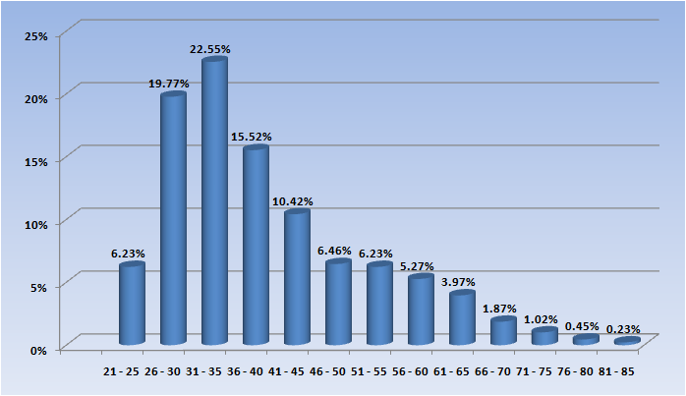

Osteopaths: Gender by state and territory by registration type
Sex | State | General | Limited | Non-practising | Total Count | % By Sex By State
 |  |  | Postgraduate training or supervised practice
Female | ACT | 11 |  | 1 | 12 | 0.68%
Female | NSW | 197 |  | 10 | 207 | 11.73%
Female | QLD | 56 |  | 4 | 60 | 3.4%
Female | SA | 19 |  |  | 19 | 1.08%
Female | TAS | 28 |  |  | 28 | 1.59%
Female | VIC | 219 |  | 26 | 245 | 13.88%
Female | WA | 21 |  |  | 21 | 1.19%
Female | Not Stated | 5 | 1 | 3 | 9 | 0.51%
Female | Sub total | 556 | 1 | 44 | 601 | 34.05%
Male | ACT | 18 |  |  | 18 | 1.02%
Male | NSW | 294 |  | 7 | 301 | 17.05%
Male | NT | 1 |  |  | 1 | 0.06%
Male | QLD | 89 |  | 1 | 90 | 5.1%
Male | SA | 13 |  | 2 | 15 | 0.85%
Male | TAS | 13 |  |  | 13 | 0.74%
Male | VIC | 138 |  | 7 | 145 | 8.22%
Male | WA | 28 |  |  | 28 | 1.59%
Male | Not Stated | 13 | 1 | 2 | 16 | 0.91%
Male | Sub total | 607 | 1 | 19 | 627 | 35.52%
Not Stated | NSW | 5 |  |  | 5 | 0.28%
Not Stated | QLD | 3 |  |  | 3 | 0.17%
Not Stated | SA | 2 |  |  | 2 | 0.11%
Not Stated | TAS | 2 |  |  | 2 | 0.11%
Not Stated | VIC | 506 |  | 9 | 515 | 29.18%
Not Stated | WA | 2 |  |  | 2 | 0.11%
Not Stated | Not Stated | 5 |  | 3 | 8 | 0.45%
Not Stated | Sub total | 525 |  | 12 | 537 | 30.42%
Total |  | 1,688 | 2 | 75 | 1,765

Osteopaths: Endorsement type by state/territory
Endorsement | VIC | Total
Acupuncture | 3 | 3
Total | 3 | 3

